**BOLD <b>**

By enclosing words in the tags <b> and </b> we can make characters appear bold.

The <b> element also represents a section of text that would be presented in a visually different way in a paragraph (For example key words in a paragraph) although the use of the <b> element does not imply any additional meaning.

**Exercise - bold**

<!DOCTYPE html>

<html>

<head>

<title>Bold</title>

</head>

<body>

<p>This is how we make a word appear <b>bold.</b></p>

<p>Inside a product description you might see some <b>key features</b> in bold</p>

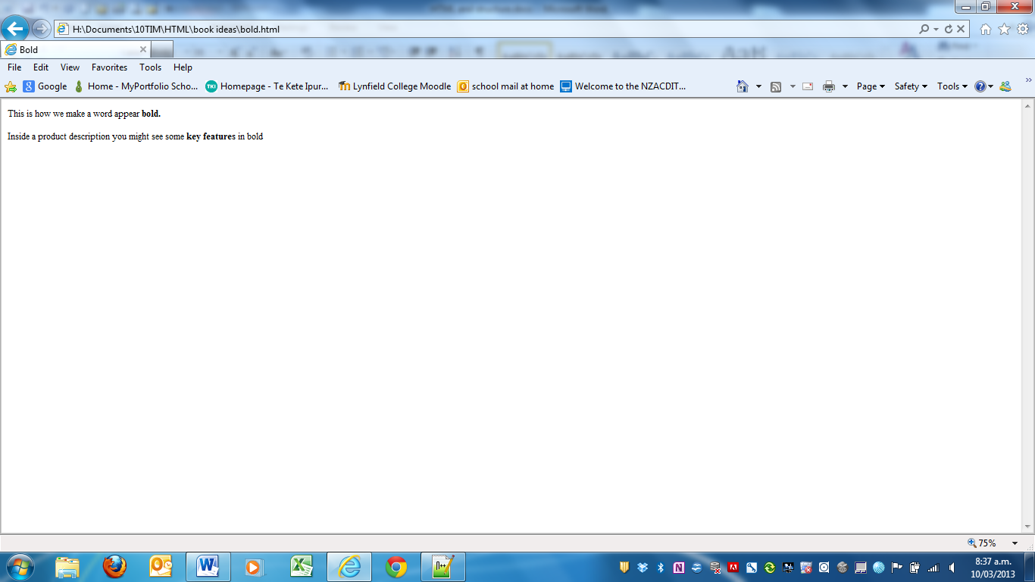</body>

</html>

**ITALICS <i>**

By enclosing words in the tags <i> and </i> we can make characters appear italic.

The <i> element also represents a section of text that would be said in a different way from surrounding content – such as technical terms, names of ships, foreign words, thoughts, or other terms that would usually be italised.

**Exercise - italics**

**Coding**

<!DOCTYPE html>

<html>

<head>

<title>italics</title>

</head>

<body>

<p>This is how we make a word appear <i>italic.</i></p>

<p>This is a potato <i>Solanum tebersum</i></p>

<p>Captain Cook sailed to New Zealand on the <i>Endeavour</i></p>

</body>

</html>

**Result**

This is how we make a word appear *italic.*

This is a potato *Solanum tebersum*.

Captain Cook sailed to New Zealand on the *Endeavour*.

**SUPERSCRIPT <sup> & SUBSCRIPT <sub>**

The <sup> element is used to contain characters that should be superscript such as the suffixes of dates of mathematical concepts like raising a number to a power such as 22.

The <sub> element is used to contain characters that should be subscript. It is commonly used with footnotes or chemical formulas such as H20.

**Exercise – Superscript & Subscript**

**Coding**

<html>

<head>

<title>superscript and Subscript</title>

</head>

<body>

<p>On the 4<sup>th</sup> of September you will learn about E=MC<sup>2</sup></p>

<p>The amount of CO<sub>2</sub> in the atmosphere grew by 2ppm in 2012<sub>1</sub></p>

</body>

</html>

**Result**

On the 4th of September you will learn about E=MC2.

The amount of CO2 in the atmosphere grew by 2ppm in 20121.

**WHITE SPACE**

In order to make code easier to read, web authors often add extra spaces or start some elements on new lines.

When the browser comes across two or more spaces next to each other, it only displays one space. Similarly if it comes across a line break, it treats that as a single space tool. This is known as **white collapsing space.**

**Exercise – White space**

**Coding**

<html>

<head>

<title>White Space</title>

</head>

<body>

<p>The moon is drifting away from the earth.</p>

<p>The moon is drifting away from the earth.</p>

<p>The moon is drifting away from the earth.</p>

</body>

</html>

**Result**

The moon is drifting away from the earth.

The moon is drifting away from the earth.

The moon is drifting away from the earth.

**LINE BREAKS <br />**

As you have already seen, the browser will automatically show each new paragraph or heading on a new line. But if you wanted to add a line break inside the middle of a paragraph you can use the line break tag <br />.

**Exercise – line breaks**

**Coding**

<html>

<head>

<title>line breaks</title>

</head>

<body>

<p>The Earth<br />gets one hundred tons heavier every day<br />due to falling space dust.</p>

</body>

</html>

**Result**

The Earth  
gets one hundred tons heavier every day  
due to falling space dust.

**HORIZONTAL RULES <hr />**

To create a break between themes –such as a change of topic in a book or a new scene in a play – you can add a horizontal rule between sections using the <hr /> tag.

There are a few elements that do not have any words between an opening and closing tag. They are known as **empty elements** or **void tags** and they are written differently.

An empty element usually has only one tag. Before the closing angled bracket there will often be a forward slash character. Some web page authors miss this out but it us a good habit to get into.

**Exercise – horizontal rules**

**Coding**

<html>

<head>

<title>horizontal rules</title>

</head>

<body>

<p>Venus is the only planet that rotates clockwise.</p>

<hr />

<p>Jupiter is bigger than all the other planets combined.</p>

</body>

</html>

**Result**

Venus is the only planet that rotates clockwise.

Jupiter is bigger than all the other planets combined.

**Task**

Create a web page that says:

HTML gives me the POWER to

Reach out to people through the web

And

To show how smart I am.